SISTER NIVEDITA MONTESSORY SCHOOL
HINDI
CLASS – U.K.G

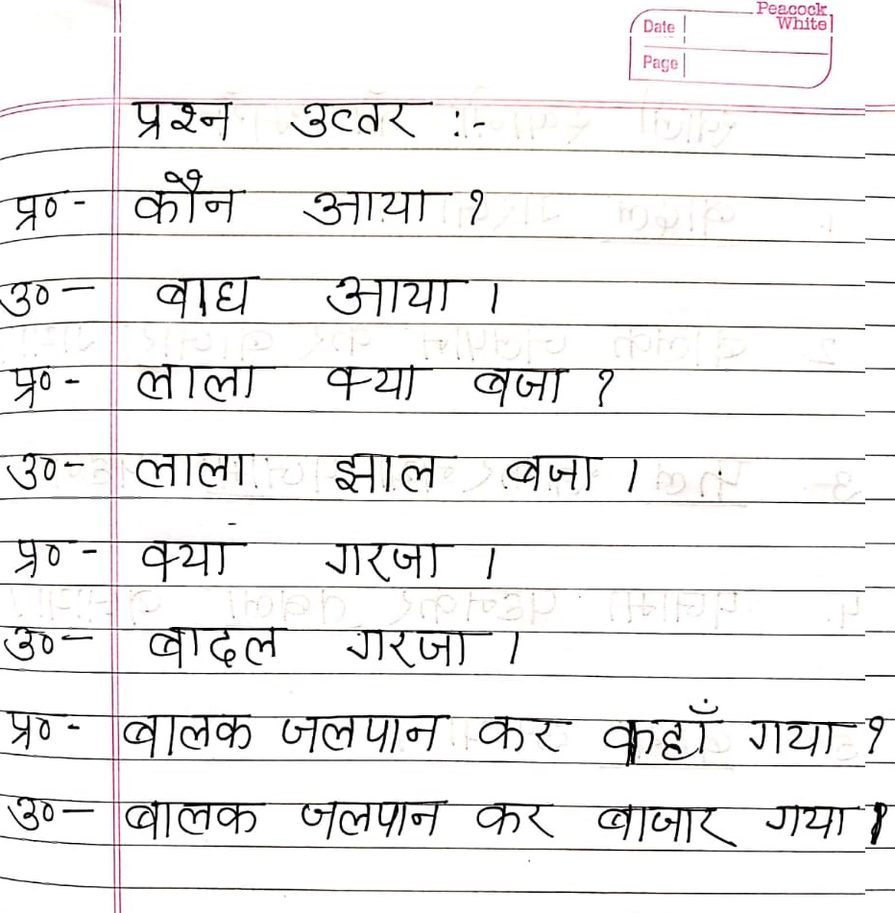
ABHYASHY PUSTIKA PG.NO- 1,2,3&4

